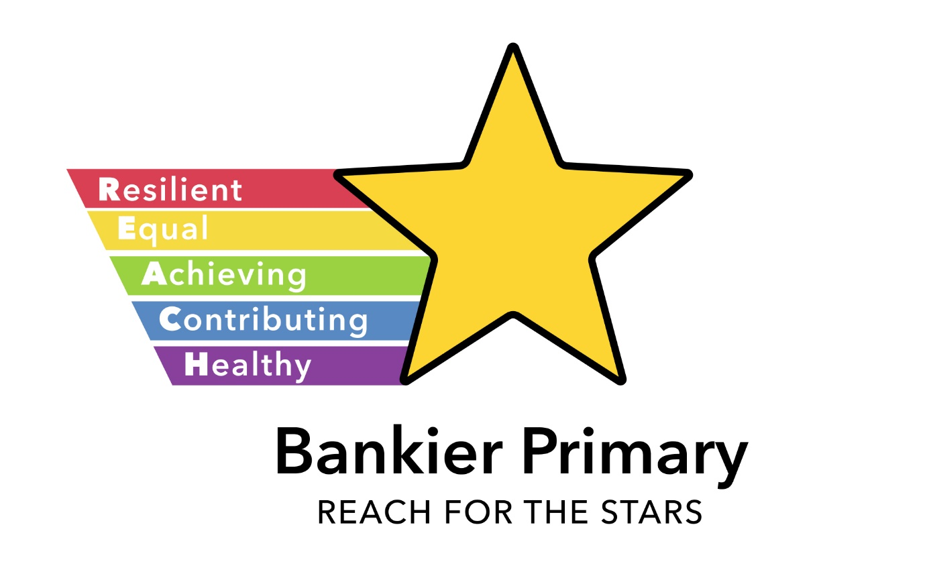
BANKIER PRIMARY

School Handbook

2025-2026
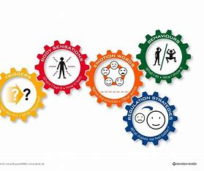





Contents

Foreword from the Director of Children’s Services

Curriculum for Excellence

Welcome from the Head Teacher

1. Practical Information about the School

School Contact Details

Communicating with the School

School Policies

2. Parental Involvement in the School

School Ethos

3. School Curriculum

Assessment and Reporting your Child’s Progress

4. Support for Pupils

Transitions – Moving to a New School or Leaving School

5. School Improvement

A Foreword from the Director of Education
Session 2025-2026

This handbook contains a range of information which we hope will be of interest to you and your child. It offers an insight into the life and ethos of the school, along with advice and assistance to support and engage you in your child’s education.

Falkirk Council is committed to partnering with parents to enhance involvement in their children's education and the broader school community. One of the most effective ways to engage is by joining the school's Parent Council. Parent Councils are independent bodies that collaborate with schools to improve education and foster strong home-school partnerships. By joining a Parent Council, you can voice your ideas, contribute to key decisions, and ensure parents' perspectives shape the school's priorities and activities, ultimately enriching the educational experience for all young people.

Throughout the school year, there will be opportunities to discuss your child's progress with their teacher(s) and through the ‘Progress’ reporting system/app. To stay updated on school activities and news, follow your school's social media accounts, as well as central accounts like @CSCommsFalkirk, @ConnectedFalk, and @falkirkcouncil, where we share important information and success stories.

We are fortunate that the Council supports our ‘Connected Falkirk’ programme, ensuring that all young people from P6 to S6 have their own personal learning device. This allows them to access their learning resources anytime and review the feedback provided by their teachers. Not all young people in the country have their own personal device, so we encourage you to ask your child to show you what they are learning. It is a great way to see how they are progressing and provides a flavour of the work being undertaken.

I took up the post of Director of Education in May 2024 and ensured that during my first few weeks I visited every establishment in our Council area, meeting with staff and young people, and witnessing the excellent work carried out by our dedicated and committed teams. Falkirk is proud of the positive destinations our school leavers achieve and the high levels of attainment across our schools. This success is a testament to the hard work of our young people, the quality of classroom experiences, and the support from teachers and families. I look forward to seeing more of that in the months and years that lie ahead.

I trust that this handbook will provide you with all the relevant information you may need concerning your child’s school. If you have any queries regarding the contents of the handbook, please contact the Head Teacher of your child’s school, who will be happy to offer any clarification required.

Jon Reid
Director of Education
Falkirk Council

Footnote: If you want a printed copy of this handbook, please ask the school.
It may be possible to offer some assistance in helping to translate all or part of this handbook to parents whose first language is not English. Enquiries should be directed in to the Communications Officer for Children’s Services (tel: 01324 506657)
Disclaimer
The information in this school handbook is considered to be correct at the time of publication (Dec 2024), however, it is possible that there may be some inaccuracy by the start of the school term in August 2025.

Curriculum for Excellence - Learning to Achieve

Learning Entitlements

In addition to the entitlements of Curriculum for Excellence our education provisions will reflect local needs and circumstances. Therefore, at different stages of their education, our learners will have opportunities to:

Link aspects of their learning to the local environment and its heritage
Participate on a residential experience where possible
Participate in arts, sports and cultural events
Participate in integrated, hands-on learning for sustainability, fostering global citizenship, critical thinking, and lifelong skills
Participate in outdoor learning experiences
Equitable access to technology for learning, including digital devices, internet connectivity, and the development of digital literacy skills.
Be consulted on and contribute to the decision-making process in school
Access to vocational and work-based learning experiences that provide practical skills, industry exposure, and pathways to employment.
Develop leadership and social skills through collaborative projects, extracurricular activities, and active participation in school and community initiatives
Access learning experiences designed and / or delivered by relevant partners
Reflect upon and be proactive in planning and making choices about their own learning
Engage with learners in other countries where appropriate and demonstrate knowledge of their culture.

How can you help?
By law, you must make sure your child receives education.
As a parent, you can help your child by:

- Ensuring regular and punctual attendance
- Encouraging and facilitating home learning opportunities and study routines where appropriate
- Attending parent-teacher meetings/discussions and school events.
- Discussing school reports with your child
- Encouraging reading and educational activities outside of school
- Supporting participation in extracurricular activities and clubs
- Discussing what was learned at school and showing interest in their education.
- Setting high expectations and celebrating achievements
- Helping them develop good organisational and time-management skills
- Promoting healthy eating and adequate sleep at home
- Encouraging a positive attitude towards learning and school
- Collaborating with the school on individual education plans where appropriate
- Participate on a residential experience where possible

Throughout this handbook the term ‘parent’ has the meaning attributed in the Standards in Scotland's Schools Act 2000 and the Scottish Schools (Parental Involvement) Act 2006. This includes grandparents, carer or anyone else who has parental responsibility for the child.

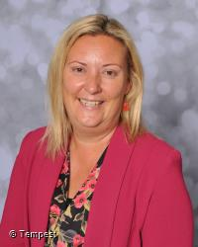
Welcome from the Head Teacher

Dear Parent / Carer,

The staff, pupils and parents of Bankier Primary School would like to extend a very warm welcome to all families.

Bankier Primary School has served the villages of Banknock, Longcroft, Coney Park and Haggs since 1964. Whilst education continues to undergo many changes, in order to prepare children for the demands of a rapidly changing world, the motto at Bankier remains- Reach for the Stars!

Our handbook provides an overview of our ethos, values and vision and gives our most recent performance information relating to literacy, numeracy and health and wellbeing.

From our ELC to Primary 7, staff seek to work in partnership with parents. Only by home and school working together can we ensure the best possible progress for each pupil. I hope this brochure will provide a helpful introduction to Bankier Primary School, to our vision, aims, curriculum and organisation. If you would like any further information, please contact the school and we will be delighted to help.

I look forward to a co-operative and productive partnership with all pupils, staff and parents.

Yours faithfully,

Sarah Ritchie Sonia Brown
Communication Environment Award Bronze
Headteacher Chair of Bankier Helping Hands

Meet the Staff

 |  |  | 
Mrs Sarah Ritchie  Head Teacher | Mr Stuart Mc Farlane  Depute Head Teacher | Mr Iain Farrington  Acting Principal Teacher | Mrs Laura Brown  Senior Early Years Officer
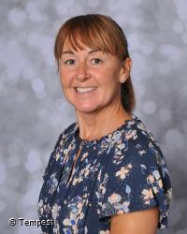 |  | 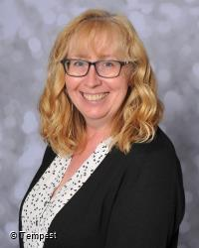 | 
Mrs Louise Noble  Eary Years Officer | Mrs Lynn Przybylinski  Early Years Officer | Mrs Grace Wright  Early Years Officer | Mrs Amanda Livingston  Early Years Officer
 | 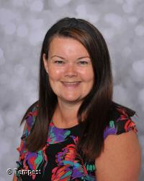 |  | 
Ms Mac Kenzie  ELC Classroom Assistant | Mrs Caroline Doctor  Early Years Officer | Mr Scott Hendry  Early Years Assistant | Mrs Saryia Riaz  Early Years Assistant
 |  |  | 
Miss Harris  Primary 1 Class Teacher | Miss Callaghan  Primary 2 Class Teacher | Mrs Buchanan  Primary 3 Class Teacher Mon-Wed | Mrs Chok  Primary3 Class Teacher Thur-Fri
 |  |  | 
Miss Mc Phee  Primary 5 Class Teacher | Mrs Barrie  Primary 6 Class Teacher | Miss Crooks  Primary 7 Class Teacher | Mrs Robertson  ASN Teacher

 |  | 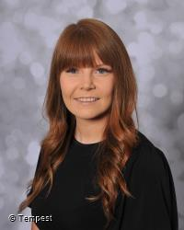 | 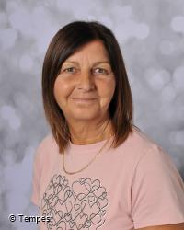
Mrs Kee  Support Teacher | Mrs Comrie  Maternity Leave | Mrs Paddon  Maternity Leave | Mrs O’Brien  Support Assistant
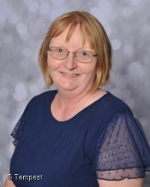 | 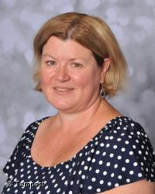 |  | 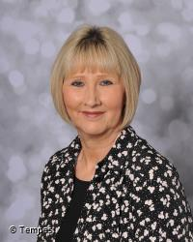
Mrs Kirk  Support Assistant | Mrs Curle  School Cleric Officer | Miss Gibson  Support Assistant | Mrs Gray  Support Assistant

To make our handbook easy to use I’ve divided the information into five different sections :-

Section One – Practical Information about the School
This section provides you with some background information on our school (and our early learning and childcare class). It tells you how our school day and school year are made up and how to contact the school if, for example, your child is ill.

This section deals with the practical aspects of your child’s attendance at our school. It provides details on such things as:

- travelling to and from school
- school meals and milk
- financial assistance with school clothing, transport and school meals
- school closures in an emergency or unexpectedly for any reason
- general supervision available for your child in the morning and at lunchtime
- wet weather details
- how the school communicates with parents
- how to raise concerns if you are not happy about something.

As with any organisation, to ensure smooth running and appropriate maintenance of standards, a range of procedures and policies have to be implemented within our school.

This section gives an overview of the policies the school has in place. If you would like to see a full copy of these policies or to discuss them in more detail, please contact me.

Section Two – Parental Involvement in the School

Parental involvement and contribution is very important as we know it helps children do better in school.

This section contains information about how parents can be involved in supporting learning at home as part of a home – school partnership.

You can also find out more about the ethos of the school, what our values are and our aspirations for our pupils including how we celebrate pupil success, and links we have with partner organisations and the wider local, national and international community.

Lastly, it includes information on our Parent Teacher Association/Parent Association and Parent Council, how to contact them and how parents can get involved in the life and work of the school.

Section Three – School Curriculum
This section describes how the curriculum is planned and delivered in the school including the range of subjects and subject areas your child will be learning. It also includes information on how pupils develop skills for learning, life and work, including literacy, numeracy and health and wellbeing in and out of the classroom.

As well as giving you information about the statutory curriculum requirements we have included details on sports and outdoor activities available to pupils and the range of facilities available within the school.

Details of how parents will be informed about sensitive aspects of learning e.g. relationships, sexual health, parenthood and drugs awareness are included as well as information about religious instruction and observance and arrangements for parents who wish to exercise their right to withdraw their child.

This handbook also tells you how we will report on your child’s progress and what written reports may be sent out to parents.

Section Four – Support for Pupils
This section gives information about how pupils’ additional support needs will be identified and addressed and the types of specialist services provided within our school. This handbook also explains who to contact for more information if you think your child has additional support needs.

This section also gives information about transition – from primary school to secondary school – what the arrangements are and contact details of the catchment high school to which our pupils normally transfer. There are also details about making a placing request to another school.

Section Five – School Improvement
The section gives you an overview of the main achievements of the school within the last 12 months and performance information relating to literacy, numeracy and health and wellbeing.

Whilst Falkirk Council is happy to provide this information we do have some reservations that the publication of raw statistics, without any kind of informed qualification, can be misleading to the reader. In particular, they should not be construed as offering an indication of the quality of education provided in any of our schools.

We have also shown where you can get further information about our plans for the next three years to improve our performance and how the school will involve parents in that improvement.

I hope you find all of the above information helpful and self-explanatory. If you have any queries about any of the information contained in this handbook, or indeed about any aspect of our school, please do not hesitate to contact me.

Mrs Sarah Ritchie
Head Teacher
Mrs Sonia Brown
Parent Council Chair
Bankier Primary School

Section One – Practical Information about the School

Contact Details
School Address: Bankier Road
Banknock
Bonnybridge
Stirlingshire
FK4 1TF
School Tel No: 01324 840206
Nursery Tel No: 01324 849971
Kitchen Tel No: 01324 840230
Community Wing Tel No: 01324 841419
School e-mail address: bankierprimaryschool@education.falkirk.sch.uk

About the school

The school is non-denominational.

Stages of School: Nursery
Primary 1 to Primary 7
School Roll: 167
Nursery Roll: 32 full day

Organisation of the School Day
Start Time 9am

Morning Break 10.30am

Lunch Time 12.15pm

Finish Time 3pm

Gym days are spread across the week and class teachers will share these with parents

Assembly takes place on a Friday.

FALKIRK COUNCIL: CHILDREN’S SERVICES

Agreed Term Dates for Session 2025-2026

School year

Autumn Term begins (for pupils) Wednesday 13 August 2025
Autumn Term ends Friday 10 October 2025

Winter Term begins Monday 27 October 2025
Winter Term ends Friday 19 December 2025

Spring Term begins Monday 05 January 2026
Spring Term ends Thursday 02 April 2026

Summer Term begins Monday 20 April 2026
Summer Term ends Friday 26 June 2026

Term Time Public Holidays

- Monday 8 September 2025
- Friday 13 February 2026
- Monday 16 February 2026
- Monday 04 May 2026

Staff Development Days

- Monday 11 August 2025
- Tuesday 12 August 2025
- Friday 28 November 2025
- Tuesday 17 February 2026
- Friday 01 May 2026

Registration and enrolment
The date for registration of new P1 school entrants is advertised in all local nurseries, schools, the local press and on the council’s website www.falkirk.gov.uk. Pupils should be registered in only one school for their catchment area. Parents will be provided with information about the school, when they register their child.

Pupils who are baptised Roman Catholic are automatically entitled to enrol at the denominational catchment school. All other pupils must make a placing request to attend a denominational school.

Parents who want to send their child to a school other than the catchment school must make a placing request in addition to enrolling their child at their catchment school. Please refer to section four of this handbook for more information on placing requests.

Parents of pupils who have moved into the catchment area or, who wish their child to transfer to the school, should contact the school office for information.

Parents can also make a formal request for their child to attend Gaelic Medium Education. Falkirk does not currently have a school with Gaelic Medium Education, however if there is a request for 5 or more preschool children to attend Gaelic Medium Education the following year, we would do our upmost to accommodate this. Otherwise we can support parents in applying to a Gaelic Medium School in a neighbouring authority.

Attendance and absence
It is the responsibility of parents of a child of school age to make sure that their child is educated. Most do this by sending their child to school regularly. Attendance is recorded twice a day, morning and afternoon.

Percentage | Number of School Days Annually | Number of days missed
100% | 190 | 0
95% | 180.5 | 10 days (2 weeks)
90% | 171 days | 19 days (3 weeks, 4 days)
85% | 161 days | 28 days (5 weeks, 3 days)

Absence from school is recorded as ‘authorised’ i.e. it has been approved by the education authority, or as ‘unauthorised’ i.e. the absence remaining unexplained by the parent.
Please let the school know by letter, email to the school’s generic address or phone if your child is likely to be absent. If there is no explanation from a child’s parents / carers, the absence will be regarded as unauthorised.

Please make every effort to avoid family holidays during term time as this disrupts your child’s education and reduces learning time. In certain extreme situations, the head teacher can approve absence from school for a family holiday for example, in exceptional circumstances where the holiday would improve the cohesion and wellbeing of the family. Please discuss your plans with the head teacher before the holiday. If the head teacher does not give permission before the holiday, it will be recorded as unauthorised absence. The head teacher may also exercise discretion when a parent can prove that work commitments make a family holiday impossible during school holiday times. Normally, your employer will need to provide evidence of your work commitments. Absence approved by the head teacher on this basis is regarded as authorised absence.

Parents from minority ethnic and/or religious communities may request that their children be permitted to be absent from school to celebrate recognised religious and/or cultural events. Absence approved by the head teacher on this basis is regarded as authorised absence. Extended leave can also be granted on request for families returning to their country of origin for cultural or care reasons.

A supportive approach is taken to unexplained absence. However, the education authority has legal powers to write to, interview or prosecute parents, or refer pupils to the Reporter to the Children’s Panel.

School Dress Code
Parents are asked to co-operate with the school in encouraging their child to follow the school’s dress code.

All schools have a dress code, which includes the school’s policy on uniform. The wearing of uniform is encouraged as it helps to:
- develop a school community spirit
- improves school security by making non-pupils more easily identifiable
- allows pupils to be easily identified when out of the school, e.g. on trips
- enhances the school’s reputation within the community; and
- minimises rivalry and bullying amongst pupils that can arise from, for example, the wearing of designer clothing.

The school’s dress code has been agreed in consultation with parents, pupils, staff and the Parent Council. This consultation has ensured that the dress code meets the needs of the school community, allows pupils to participate in all aspects of school life and is age appropriate.

Branded items can be purchased from Logo Express in Stirling. A selection of good quality pre-loved items are always available from the school.

The appropriate clothing and footwear for PE is T-shirt, shorts, leggings or jogging trousers, and gym shoes with non-marking soles. These are necessary for health and safety reasons and your co-operation is requested to ensure that pupils are equipped to participate in the PE lessons.

Please ensure that all items of clothing are clearly labelled, particularly ties, sweatshirts and PE equipment, which are often lost. A protective apron or an old shirt should be worn for art and craft activities. Please help the school and the education authority by making sure that pupils do not bring valuable or expensive items of clothing to school.

In certain circumstances, appropriate clothing will be necessary for school activities for safety reasons, e.g. in games areas, science laboratories and technical workshops; this extends to the wearing of suitable footwear and even, on occasion, to the length of pupils’ hair and the wearing of jewellery and earrings.

Offensive clothing such as T-shirts or other items featuring inappropriate language or illustrations is not permitted. Football colours are also inappropriate as they can lead to incidents of rivalry.

If you have any queries regarding the school’s dress code, please contact the Headteacher.

School Meals
Primary and Secondary Menus offer healthy and tasty meal options whilst reflecting the Scottish Government food and drink legal requirements for School Lunches.

Primary School Menus provide 3 daily choices with 2 portions of veg and 1 portion of fruit included with every meal choice with High Schools providing a range of plated meals, pasta, meal deals and salad boxes. 2 portions of veg and 1 portion of fruit are included with every meal choice within the balanced core High School menu.

Meal prices are reviewed annually. Please contact your child’s school to be advised of the current price.

All P1-5 pupils are entitled to a free school meal. In the case of P6-P7 and secondary aged pupils, some families may be eligible to apply to Falkirk Council for provision of free school meals. Further details can be obtained from your child’s school.

Bankier Primary School has a breakfast club which runs from 8.30am until 9am. Pupils can enjoy a nutritious breakfast in a relaxed atmosphere. Pupils who are eligible for a Free School meal can attend free of charge. There is also the option to pay:

If you wish a place at the Breakfast Club, please contact the main office.

Medically Prescribed Diets
Parents/Carers with a child/ren on a medically prescribed diet should request a prescribed diet referral and declaration form from the School Office. The School Meals Service can only accommodate a child/ren with a medical referral diagnosed by a medical professional. Delay in returning the completed diet form could result in reduced meal options being offered.

IPAY

All the pupils have been given a letter which details the new electronic system available to parents, carers and others to pay for school meals, trips etc. Each pupil has their own unique reference so if you have two or more children in the family you must add in all the reference codes to be able to access that child account.

Setting up your ipay account is very easy.

In order to use the Falkirk Council iPayimpact web site you must have a Mygovscot account. To create one:

Visit: http://www.falkirk.gov.uk/do-it-today/pay/schools/
  - Click on Register for an account and Register for a Mygovscot account
  - Complete the 4 steps to create a Mygovscot account
Once registered and your account verified, go back to
http://www.falkirk.gov.uk/do-it-today/pay/schools/
  - and select Sign In
- On first sign in, after accepting terms and conditions, you will be asked to provide the Account Ref for one of your children to make payments on their behalf. This Account Reference can be found at the top of this letter. Enter the reference provided for one of your children and select Link Account.
- Link additional child/ren (if you have more than one child at this school or another school using Falkirk Council iPayimpact)
  - Go to Accounts on the top menu – your first child will be displayed.
  - Click on the ‘Link a New Account‘ button
  - Enter the Child Account Reference for your other child/ren as detailed in this letter or similar letter from another school.
  - Click Find Account and Establishment – choose the school from the list (if displayed)
  - Click the Link Account button

MAKING A PAYMENT
- Go to the home page and add items you wish to pay for into the basket
- Proceed to Checkout
- If you still wish to pay in cash you may do so. You can either send money in daily or send in a lump sum e.g., £10.25 a week, £20 etc and this will be added by the school to your child’s dinner money Ipay account. We will be putting future school trips on the Ipay system so even if your child is in receipt of free school meals you may wish to activate the account in order to pay for this. Please make sure that if you are sending money into the school that it is in an envelope with the child’s name, class and also details of what the payment is for.
- If you require any assistance with the Ipay system please contact us and we will do our best to assist.

Medically Prescribed Diets
Parents/Carers with a child/ren on a medically prescribed diet should contact the Headteacher in order to obtain and complete a prescribed diet referral and declaration form. The Schools Meals Service will only accommodate a child/ren with a medical referral diagnosed by a medical professional.

Free School Meals and Clothing Grants

Falkirk Council provide Free School Meals, and financial support towards the cost of School Clothing and Footwear for families that meet certain eligibility criteria.

Do I qualify for an award?
- To be eligible, you should normally be resident in the Falkirk Council area and your child(ren) must attend any primary, special or secondary school managed by Falkirk Council.

What is the Current Value of Clothing Grants?
- For 2024/25 the Clothing Grant is £125.00 per child/per year for primary school aged children and £155.00 per child/per year for secondary school aged children.

Do I Need to Apply if My Children are in Primary 1 to Primary 5 and receive Universal Free School Meals?
- Free School Meals –Families who meet the eligibility criteria for free school meals should apply for free school meals regardless of the universal provision. This informs your eligibility for other benefits and signposting to additional household support if needed. However, you do not need to apply for Free School Meals to access universal free school meal provision if your child is in Primary 1-5.
- Clothing Grants – Yes, you still need to apply for Clothing Grant for these pupils.

How is Eligibility Assessed?
- Assessment of eligibility is generally based on your household income/circumstances.
- There are different qualifying thresholds for Free School Meals and Clothing Grant awards.
- The qualifying criteria can be found on our website here: www.falkirk.gov.uk/fsm.

Will I need to submit an application form?
- No - If you received an award during the 2024/2025 school year and you have already been contacted to advise you do not need to re-apply.
- Yes - If you have never applied before or if you did not receive an award during the 2024/2025 school year.

How Do I Apply?
- You should apply online: www.falkirk.gov.uk/fsm
When will I receive my award?
- We aim to assess applications within 28 days of receiving them. Please make sure that you provide all of the necessary evidence with your application form in order for us to complete our assessment, otherwise any entitlement and awards may be delayed.

Further Information
- More information regarding Free School Meals and Clothing Grant can be found on our website and FAQ’s at www.falkirk.gov.uk/fsm.

Other Support

There are other sources of support which may be available to families, depending on your circumstances.

- Best Start Grant: Pregnancy and Baby Payment – Payments for parents of new-borns, or those currently expecting.
- Best Start Foods – Payments for parents of children up to 3 years old.
- Best Start Grant: Early Learning Payment – Payment for parents with children aged between 2 and 3 and half years old.
- Best Start Grant: School Age Payment – Payment for parents of children starting Primary School.
- Education Maintenance Allowance (EMA) – Financial support for 16 -19 year olds continuing at high school.
- Young Scot – The Young Scot National Entitlement Card is available free of charge to everyone aged 11-25 living in Scotland. It can be used to receive discounts, for rewards, and also as proof of age.
- Young Persons' Free Bus Travel Scheme - Young people aged between 5 and 21 years old are eligible for free bus travel from 31 January 2022.
- Help with Welfare Benefits – Find out if you are claiming all of the support you are entitled to and speak to an adviser for further advice.
- Other support for families - Any family facing financial insecurity can also contact our Support for people team for assistance or sign posting to other support. The team can be contacted on 0808 100 3161.

School Holiday Support Payments
A payment of £2.50 per day as an alternative to free school meal provision during the school holidays. This provision will cover the summer holidays; the Christmas and Easter holidays during the 2025-26 school year; and also the mid-term holidays in October and February.

This payment will be made to children and young people who are awarded free school meals based on the Scottish Government eligibility criteria. To be eligible for payment, children and young people must have been approved for free school meals prior to the beginning of the relevant holiday period.

How will the payment be made to parents and carers?
We will make direct payments to your bank account, using the details we hold on your Free School Meals or Clothing Grant claim. If no bank details are held on file, payments will be issued by cheque.

When will I be paid?
Payments for each eligible pupil will be made at the start of the holiday periods in Summer, October, Christmas, February and Easter

Who is not eligible for this additional support?
Pupils not eligible for this are:

- Pre-school pupils in early years establishments.
- P1-P5 pupils and those pupils in special educational settings where they receive a free meal through universal and not means-tested provision.

For further information please contact us at fsm.payments@falkirk.gov.uk

Education Maintenance Allowance (EMA)
EMA is a weekly allowance of £30 which you may be able to get if you are:
- aged 16 to 19
- attend a Falkirk school (or attend Home Education)
You'll need to meet the terms of your Learning Agreement, and will usually only get EMA for a week where you have 100% attendance.
Check if you are eligible by visiting the EMA Scotland website.

How to apply
You can apply online at Education Maintenance Allowance | Falkirk Council.
Make sure you read the guidance carefully and provide all the information that is asked, including any supporting evidence.
Please Note: You will need to complete the application with your parent/carer present as some of the questions relate to their circumstances, and they need to sign the declaration.
Make sure you submit your application even if you don't have all the information. The date that we receive your application can make a huge difference to the date we can pay you from (eg you miss the 30 September or 28 February deadlines).

Deadlines
Your age | Application date | Payment start date
16-19 on or before 30 September | Apply on or before 30 September | Payments start from beginning of August term
 | Apply after 30 September | Payments start the week we receive your application
Turn 16 between 01 October and 28 February | Apply on or before 28 February | Payments start from beginning of January term
 | Apply after 28 February | Payments start the week we receive your application

Travel to and from School
Parents should remind their child(ren) that, in the interests of safety, good behaviour is expected from all pupils travelling on school transport.

Children should be reminded by parents that, wherever possible, they should only cross the road where there is a crossing patrol and should exercise care on walking to and from school.

Parents are requested, when dropping off/collecting children from school, that they do not park near the pedestrian exit or in any location which causes an obstruction and they take care not to restrict the view of the school crossing patrol.

Transport for Primary and Secondary School Children (Excluding Placing Requests)
Free school transport is provided to and from your home address to your child’s catchment school if they are distance entitled. Falkirk Council operate a more generous distance entitlement policy than required by law.
Distance entitled children are:

- All children under 8 years of age who live one mile or over from their catchment school by the nearest available safe walking route*.
- All children 8 years of age or over who live two miles or over from their catchment school by the nearest available safe walking route*.

*Note – a “safe walking route” assumes that the pupil is accompanied by a responsible adult.

Concessions, details of times of operation, criteria and application forms are available from the Transport Planning Unit within Falkirk Council. Tel: 01324 504724 / 504966.

Pickup points
Where home to school transport is provided, some pupils will require to walk a reasonable distance from home to the transport pick-up point but this should not exceed the authority’s agreed limit of 1 mile.

It is the parent's responsibility to make sure that their child arrives at the pickup point on time and behaves in a safe and acceptable manner while boarding, travelling in and leaving the vehicle. Children who misbehave can lose their right to home to school transport.

General Supervision

Before school begins supervision is very limited, therefore pupils should not arrive at school until as near to the school start time as possible.
During intervals Support for Learning Assistants supervise the children. In addition, members of the leadership team are on call to cope with any difficulties which may arise. There is always access to the building and the children are made aware of this. For further information on these arrangements, please contact the school.

School security
Falkirk Council aims to ensure the safety and security of pupils and staff when attending or working in a school. We use a number of security measures including a visitors’ book, badges and escorts, while visitors are within the school building. Anyone calling at a school for any reason, is required to report to the school office. The school staff then can make the necessary arrangements for the visit.

Wet Weather Arrangements
In wet weather pupils may be allowed into school during breaks and at lunchtime. However, as supervision during these periods is limited. It is especially important that school rules and expectations around behaviour are adhered to by all. Children having school lunches may remain in school during wet weather but, again, supervision is limited.
Parents Meetings
All of our schools offer opportunities for parents to discuss their child's progress with teachers through arranged meetings. Arrangements vary from school to school but all parents will be advised of when these meetings will take place. In addition to these set dates, parents are able to contact the school at any time to ask for information or for a meeting. Please see section two of this handbook for more details on home / school partnership.
Communication with Home
From time to time, you will receive important and routine communications from the school via variety of methods (Class Dojo, email, group call, social media etc.). Parents are also encouraged to check their child’s schoolbag and e-mail account for these communications. Enquiries of any kind should be addressed to the Head Teacher in the first instance.

Unexpected Closures

Most closures will be notified to you in writing, in advance, but there are occasions when the children may be dismissed early without warning, e.g. as a result of power cuts or severe weather. In the event of an early school closure please ensure that your child knows where to go if you are not usually at home during the day. To help us keep you informed it is important that you make sure we have the most up to date emergency contact information for your family. We will keep in touch using text messaging, via the Falkirk Council website

Mobile devices
Parents provide their children with mobile devices for a variety of reasons, including supporting learning and for personal safety. It is the right of parents to allow their child to have a personal mobile device in school. However, if devices are brought to school there must be a clear understanding that the individual pupil is responsible for the care and usage of their device(s).
Education establishments develop their own mobile device policies in consultation with pupils, parents and staff. For more information on this topic, please contact your child’s school.

ICT Acceptable Use Policy
Falkirk Council Children’s Services recognises that access to Information and Communications Technology (ICT) equipment and services helps young people to learn and develop skills that will prepare them for work, life and citizenship in the 21st Century.

To support this, we provide resources for pupils and staff to use. The Children’s Services ICT Acceptable Use Policy (AUP) outlines the guidelines and behaviours that pupils are expected to follow when using school equipment or when using personally-owned mobile devices in Falkirk Council establishments. The purpose of this is to protect young people online and to protect the Council’s network and equipment. The ICT Acceptable Use Policy (AUP) will be issued by the school for both parent(s) and pupil(s) to sign.

Equality
The council is required to work towards advancing equality of opportunity for all people and to foster good relations between people. The council is committed to eliminating discrimination on the grounds of race, sex, disability, sexual orientation, religion/belief, age, marriage or civil partnership, transgender status, pregnancy/maternity or poverty.

Children’s Services have a range of policies and procedures to address equalities issues specific to education to enable us to fulfil these duties. In addition to this all education establishments have a responsibility to report incidents of prejudice-based bullying in line with our Anti-Bullying Policy: ‘Promoting Positive Relationships in Falkirk’s Educational Establishments’.

English as an Additional Language
As part of the Additional Support Needs Service, the Council provides a support service for children who have English as an additional language. The service supports enrolment and provides staff training and visits to schools to work with those children and young people who require assistance in developing English language skills.
This service can be contacted via email: EAL@falkirk.gov.uk

Compliments, Enquiries and Complaints Procedure

Falkirk Council Children’s Services would like you to be completely satisfied with your child's education. As a Council of the Future, we are encouraged to view complaints positively as they help us to continually improve the service we provide. We welcome/encourage feedback on our services from parents, pupils, and members of the public whether it be compliments, enquiries, or complaints.

Please let your school know if you have a compliment, enquiry or a complaint about the service provided so they can investigate and resolve any issues you or your child are experiencing as quickly as possible.

How do I complain?

Complaints can be made to schools in writing, by email, on the telephone, or in person.

Who do I complain to?

Parents must contact the school in the first instance. Any complaints received by Education Headquarters that have not been initially referred to the school will be redirected back to school to respond.

What happens with my complaint?

Complaints are logged on our online complaints handling database (Customer First). Only Children’s Services staff responsible for logging, monitoring progress or responding to complaints have access to this part of the database.

Our complaints procedure has two stages:
- Stage 1 – Frontline Resolution
- Stage 2 – Investigation

Stage 1 of our complaint’s procedure allows immediate action to be taken to resolve the problem with an on-the-spot apology or be given to a Principal Teacher or Deputy Headteacher to investigate and respond. If we can’t resolve your complaint at this stage, the next steps will be explained to you.

Complaints that have not been resolved at Stage 1 or are complex and require detailed investigation are investigated at stage 2 of our complaint’s procedure. If a complaint is escalated to Stage 2, it will be allocated to the Head Teacher or another senior member of staff to investigate and respond. Stage 2 is our final opportunity to address your complaint.

We will deal with your complaint confidentially and as quickly as possible. If we have made a mistake we will apologise and try to put things right.

How long will it take until I get a reply
We aim to resolve stage 1 complaints within 5 working days and stage 2 complaints within 20 working days. Occasionally the school may need extra time to investigate when the complaint is complex.

If your stage 1 complaint is received in the final week of term or during a school holiday period, you will be advised that your complaint will resume when staff return.

If your stage 2 complaint is received within the last 2 weeks pf term or during a holiday period, you will be advised that your complaint will resume when staff return.

Who else can help?

If you remain dissatisfied after the second investigation stage, you can raise the matter with the Scottish Public Services Ombudsman https://www.spso.org.uk/complain/form/start/

You should also be aware that you have the right to raise concerns with your local Councillor, MSP, or MP.

What else do I need to know?

Schools can only respond to complaints about a service that they or Falkirk Council provides or a service we have contracted from a third party.

The Council’s complaints handling procedure sets a time limit for making a complaint of six months from when the customer first knew of the problem.

You can find out more about the Council’s Complaint Procedure from the Falkirk Council website - http://www.falkirk.gov.uk/contact-us/complaints/

Other School Policies

The school has policies and guidelines linked to delivery of the curriculum and administrative matters. These include:

Health, Safety and Care

Positive behaviour

Learning and Teaching

All school policies can be made available for inspection in school.

Accidental Injury

We have trained first aiders on the staff who will treat minor injuries. Contact with parents is always made in the event of a more serious injury.

Emergency Evacuation Procedures
We have a very comprehensive health, safety and care policy, which incorporates emergency evacuation procedures. Each room has a map showing primary and secondary evacuation routes. At every exit we have copies of emergency evacuation procedures and the Emergency Management Plan, which are easily and quickly lifted by staff on exit. Pupils practise emergency evacuation 3 times a year, including a lunchtime fire drill. Reports of these are held on record.

The Emergency Management Plan is used to manage a very serious incident, e.g., a gas leak, bomb scare or real fire that requires we remove children from the school grounds altogether. In such cases we have arranged to locate an incident control centre at The Sports Centre or if the Sports Centre is affected, at Banknock Community Centre, Kilsyth Road, Banknock. Children would be evacuated to this centre, if necessary.

Major incidents in local industries

The biggest risk in our area is from Diageo. They offer the following guidance for safety in the event of an emergency.

Safety Advice for the Community

What to do if you hear a Public Warning Siren
The PUBLIC WARNING siren will consist of a two tone, falling and rising note operating continuously for 3 minutes followed by a 1 minute interval. The ALL CLEAR will be a continuous single note lasting for 3 minutes.
1 Go in doors immediately.
2 Close all external doors and windows and turn off ventilation.
3 Tune in to local radio for news information
BBC Radio Scotland FM 92-95 Mhz / MW 810 Mhz
Radio Clyde 1 FM 102.5 Mhz
Central FM FM 103.1 Mhz
Real Radio FM 100-101 Mhz
Emergency Safety Advice
4 Stay indoors until you receive further instructions from the Emergency Services or Diageo personnel.
5 Do not telephone the site as all lines will be required to deal with the emergency.
6 Wait until the ALL CLEAR is announced which indicates that it is safe to resume your normal activities. This will be communicated by a steady siren note and radio broadcast.

Remember the simple rule:
go in – tune in – stay in

A card listing the actions you should take in the event of the activation are available from the Manager, Diageo, Bonnybridge. Telephone 01259 722093
Control of Major Accident Hazards Regulations (CoMAH) 1999

Falkirk Council produces information about public safety that can be found here:
http://www.falkirk.gov.uk/services/council-democracy/policies-strategies/emergency-planning/major-accident-hazards.aspx

School Health Service
NHS Forth valley has a statutory obligation to provide health services for all school age children. The aim is to make sure that all children and young people, throughout their school years, are in the best possible health to benefit from their education.

School Nursing Service
School Nurses are available 8.30am-4.30pm all year round, excluding Public Holidays. School Nurses are not based in schools and are part of an integrated community team working from local health centres/clinics. The School Nurse Team offer health screening, health assessments and health reviews.
A health review is offered to all children in primary 1. This involves a parent questionnaire and the opportunity of an appointment with the school nurse to discuss any parental concerns and a review of the child’s growth.
The Falkirk School Nursing team comprises of
- Registered School Nurses
- Health care support staff
Children/young people, parents/carers can request a health appointment at any time by contacting the service on 01324 679129.
Referral to the School Nursing Service can be made by Education, Social Work, GP or other Health Care Professionals.

The School Doctor may also offer appointments to children with a significant medical or developmental condition which affects their education. School staff and parents can request a child be seen.

The Public Dental Service carries out dental inspections in Primary 1 and Primary 7 and can help access dental services for children not registered with a dentist.

Infectious diseases
Colds and tummy upsets are the most common infections affecting children at school. It is important to keep your child at home in the early stages of a cold or until at least 48 hours after an episode of diarrhoea/vomiting to prevent infecting others. For treatment of diseases such as chickenpox or mumps, please consult your GP practice or nurse.

Head Lice
Head lice are spread through head to head contact at home, whilst playing or in school. Regular wet combing of your child’s hair using a special comb is the best way to catch this problem early. Specific treatment lotions are available as shampoos are not effective. Two applications should be administered seven days apart. If this is not followed, re-infection is likely.
Further advice is available from leaflets about head lice which are available in all schools and health centres

Clinics
Some children are asked to attend clinics (eye clinics, dentist, doctor etc) Please let the school know and arrange for your child to be collected if they must leave school to attend. No child will be allowed away from school without a responsible adult or unless written permission has been received from a parent or carer.

Immunisation

Primary Schools
Flu vaccines are given every year from Primary 1 onwards by an immunisation team visiting the school. Any child who misses a session can be vaccinated by their GP. Pupils with chronic illnesses such as asthma can visit their GP at any time to receive the vaccine
.
Secondary Schools
Pupils are offered several vaccinations such as Meningitis ACWY, a catch-up for the MMR vaccine and a booster for diphtheria, polio and tetanus. From 2019 HPV vaccine will be offered to both boys and girls.
For more information: https://www.nhsinform.scot/

Medicines Administration
Administration of medicines prescribed by a doctor or dentist is at the discretion of the head teacher but most schools are happy to co-operate. Parents who wish school staff to give medicines should take the medication to school and fill in the appropriate form (MED1). It is also possible to complete another form (MED4) which allows pupils to carry and administer medication themselves, for example inhalers. Prescribed medication should be clearly marked with your child’s name, date prescribed, how often it has to be taken and for how long.

Pharmacies
Community pharmacies are trained in providing advice on coughs and colds, high temperature, fever, nasal congestion, minor eye infections, constipation, stomach upsets, fungal infections such as athlete’s foot, and skin problems such as impetigo.
For more information: nhsforthvalley.com

Insurance Cover for School Children
Public Liability
Personal Injury
Falkirk Council has in place a Public Liability policy which operates in respect of claims for injury to any third party which includes a pupil whilst under the care of the Council or their employees. In order for liability to be accepted there is an onus to evidence the council was negligible in their acts and was responsible or partially responsible for the injury sustained
Pupil’s Property
It is inevitable that during each session, pupil’s property is lost, damaged or stolen from school. Parents are therefore discouraged from allowing their children to carry expensive items of personal belongings to the school and are reminded that a standard household policy can be extended to provide a degree of cover for personal items taken away from the home. Falkirk Council are not legally responsible for pupils property which is subsequently lost, damaged or stolen, unless specifically entrusted with a member of staff.
Any claim made for loss or damage to the property left in the care of the school or its employees will have to be submitted, in the first instance to Children’s Services. Following a thorough review of the claim, settlement will only be made if it can be shown that Falkirk Council are legally liable for the loss.
Travel and Personal Accident Cover – Educational Excursions
In order to provide necessary cover for educational excursions Falkirk Council has in place an insurance policy for travel and personal accident which specifically covers any pupil enrolled at a participating establishment. The policy provides compensation for each insured pupil should an incident occur, irrespective of legal liability. There are varying degrees of benefits within the policy, but the key compensation values are noted below.

1. Death £30,000
2. Permanent Total/Partial Disablement up to £30,000

The insurance policy provides accidental bodily injury cover whilst any insured person is undertaking an organised trip (including exchange visits and work experience placement) as long as it is with the authorisation of the school or council and the activities involve a journey outside the premises of the school. The policy also extends to cover overseas travel cover.

Parents Welcome
All Falkirk Council schools welcome and encourage parental involvement and engagement. Research has shown that when parents are involved children do better in school.

Falkirk Council Children’s Services recently updated our Parental Involvement and Engagement Strategy in consultation with parents. This details a series of actions which we plan to take over a three year period to improve parental engagement with schools and the service and help to break down barriers which many parents experiencing when trying to become involved in the life and work of the school.

At Bankier Primary School we proactively encourage parental involvement across the school. At the start of the academic year we welcome parents with a Meet the Teacher session. Every class hosts an assembly and welcomes parents to join them for lunch in the school dinner hall. We have a range of social events- reading lunches, Burns’ Supper, coffee mornings and sporting events where parents are invited into the school.

The school keeps in touch with a monthly newsletter, Class Dojo, E-journals (ELC) and the School Website. The school welcomes telephone calls and e-mails from parents. Parental feedback is gathered regularly to inform school improvement and development.


Parentzone Scotland is a unique website for parents and carers in Scotland, from early years to beyond school. The website provides up-to-date information about learning in Scotland, and practical advice and ideas to support children’s learning at home in literacy, numeracy, health and wellbeing and science. Information is also available on Parentzone Scotland regarding additional support needs, how parents can get involved in their child’s school and education. Furthermore, the website has details about schools including performance data for school leavers from S4-S6; and links to the national, and local authority and school level data on the achievement of Curriculum for Excellence levels. Parentzone Scotland can be accessed at https://education.gov.scot/parentzone.

Here’s what some of our parents had to say…

My child is happy at school and enjoys his class. His teacher has identified an issues with his work and has been consulting us on steps to take to help support him.

Generally really pleased with the school and my child’s learning. Any concerns have been addressed with care.

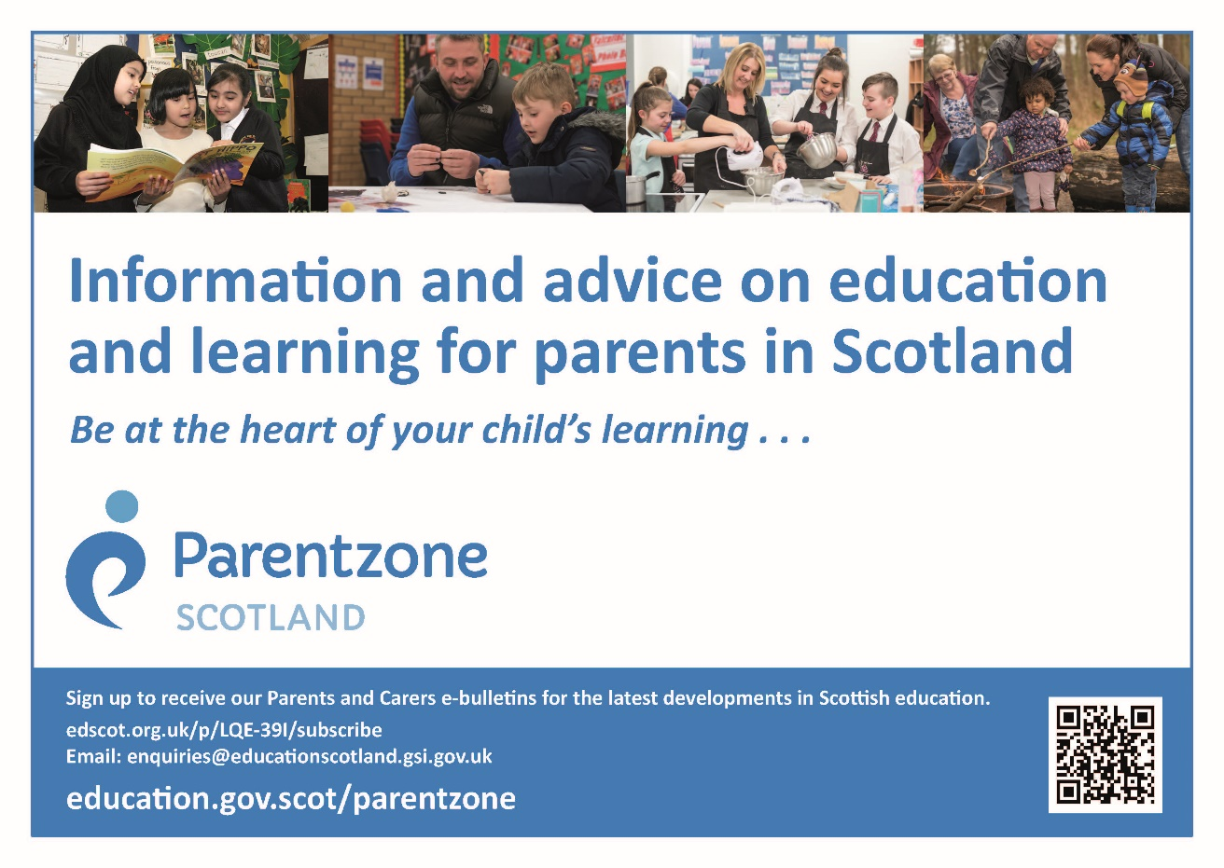
Attainment Summary

In Primary 1, Primary 4 and Primary 7 all our pupils are performing above the authority averages in Reading, Writing and Numeracy.

As a school we are very proud of how hard our pupils work and are pleased to see this reflected in our attainment levels. As a school we are further tasked with tackling the attainment gap between the most and least disadvantaged children. Since the introduction of Pupil Equity Funding, Bankier Primary school has managed to close the attainment gap through targeted interventions.

Further details of national attainment can be found on the Parent Zone Website. https://education.gov.scot/parentzone

Raising Attainment
Monitoring performance and using the resulting information to secure improvement is an important part of the work of head teachers, school staff and officers within Children’s Services. Head Teachers regularly track pupils’ progress at meetings with each teacher to ensure that progress is maintained and to identify effective strategies progress when necessary.

Parental Involvement and Engagement

We are keen to involve parents in genuine partnership wherever possible. Parents can get further involved in school life by helping to run extracurricular activities. Parents often help us escort pupils to church services at the end of term, on ‘The Big Fit Walk’ at community events such as the litter picks and on school excursions. Parents have also helped us by going on residential excursions.

We try to involve parents by sending hyperlinks to the school website and app and other important networks. GLOW, Scotland’s unique, world leading, online network supports learners and teachers. Plans are already in place for parents across the country to have access to GLOW. In the meantime, all our pupils have access to GLOW. Details of this are sent home to parents who can access GLOW though their children’s logins and passwords. We are encouraging pupils, staff and parents to make far greater use of GLOW. The school also communicates through Class Dojo and Twitter. If you log on and follow us you will receive regular updates. Please note that it is never appropriate to raise issues on social media.

We’ll consult with parents and carers at regular intervals across the session so that we can gather your views and opinions and act on them. This helps us to evaluate our performance and gives parents a voice in the school. We make every effort to be an open school and try to offer direct and easy access, responding to you within 24 hours if at all possible. We want to encourage continuous engagement with parents through homework diaries, learning journals, open days and other events.
There are website addresses with many useful contacts at the end of this handbook. (Appendix 1)

Parent Councils
Parents are welcomed to be:
- involved with their child’s education and learning;
- be active participants in the life of the school
- express their views on school education generally and work with the school.

All parents / carers are automatically members of the Parent Forum at this school. As a member of the Parent Forum all parents should –

- receive information about the school and its activities;
- hear about what partnership with parents means in our school;
- be invited to be involved in ways and times that suit you;
- identify issues you want the Parent Council to work on with the school;
- be asked your opinion by the Parent Council on issues relating to the school and the education it provides;
- work collaboratively with the school; and
- enjoy taking part in the life of the school in whatever way possible.

Parent Councils are the formal representative body for parents / carers with children attending school. Parent Councils are different in each school to enable them to meet the needs of parents / carers locally.

The Parent Forum decides how their representatives on the Parent Council are chosen and how the Parent Council operates. Parents / carers are encouraged to volunteer or put themselves forward to be chosen as representatives of the Parent Council if they wish.

The main aims of the Parent Council are:
- To support and work collaboratively with the school in its work with pupils
- To seek and represent the views of parents
- To promote contact between the school, parents, pupils, providers of nursery education and the community
- To report to the Parent Forum
- To be involved in the appointment of senior promoted staff in the school.
- To raise funds for the school for the benefit of pupils (in some schools the PTA/PA fulfils this role).
- To be included in School Improvement Planning

Please contact the Headteacher or Chair of BHH, Mrs Sonia Brown, via the school for details on how you can get involved.
For more information on parental involvement and engagement or to find out about parents as partners in their children’s learning, please contact the school or visit the Parentzone website at https://www.education.gov.scot/parentzone/

In consideration of barriers such as childcare and busy working lives, Parent Council and BHH meetings take place in the evenings.
The Fundraisers group is mainly responsible for arranging events for pupils and parents and raising funds for the school. Volunteers are welcome – please contact BHH if you want to join in. The Chairperson of the Fundraisers group is Sonia Brown. BHH may be contacted via the School or by email: bankierprimarypta@gmail.com
Connect (formerly the SPTC) the national organisation for PTAs and PAs in Scotland, Parent Councils are members too, and it runs an independent helpline service for all parents. They can be contacted by phone on 0131 474 6199, via website https://connect.scot/, email on info@connect.scot or write to Connect, Mansfield Traquair Centre, 15 Mansfield Place, Edinburgh, EH3 6BB.

School Ethos
The ethos of our school is encapsulated in our key purpose, vision, values, motto and aims. This also underpins the rationale for our curriculum.

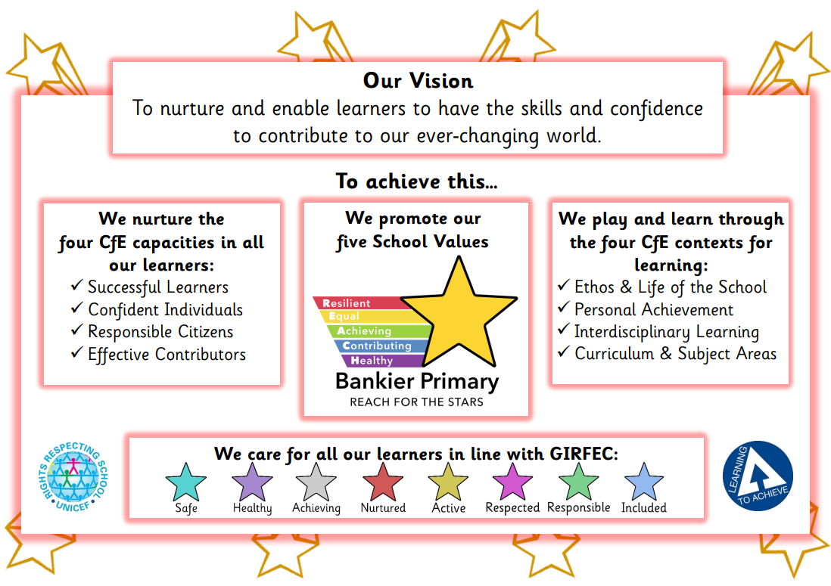

Our high aspirations for our pupils permeates our curriculum and policies. Bankier is a very effective learning community where staff and pupils engage in lifelong learning. We operate in a culture of continuous improvement. We are committed to restorative approaches and are solution focused in managing behaviour. Adults in the school work in partnership to develop resilience and pupils are taught peer mediation and conflict resolution strategies. Pupils, parents and staff have a strong voice in the school. We have a Rights Respecting Schools committee made up of representatives from every class chosen by their peers. These pupils consult their peers regularly and represent their views at committee meetings.

Good work is routinely rewarded with Dojo points. We celebrate wider pupil achievements at assemblies. Pupils receive Super Star certificates for any achievements out of school. We also give out Brilliant Bairn Certificates to children who demonstrate hard work and a positive attitude to learning and Praise Post cards when children have done something well.

The school has a House System and pupils regularly earn points for good behaviour and good work.

School Rules

Everything that we do at Bankier Primary School is underpinned by our motto, Reach for the Stars and our values,
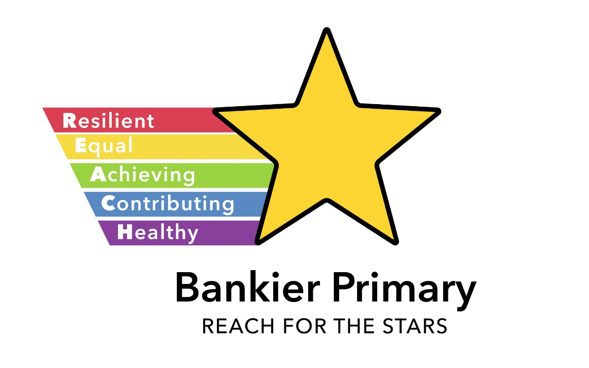

Article 28 of the UNCRC states that children have the right to an education.
The overall aim of this policy is to create a culture of positive learning and behaviour in which incidents are reduced through the use of an agreed framework for action.

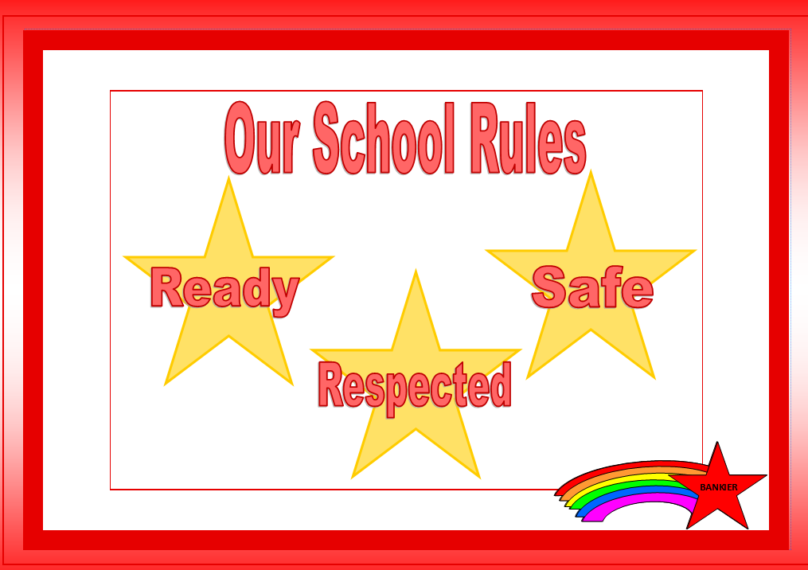
Bankier Primary School is committed to creating an environment where exemplary behaviour is at the heart of productive learning. Our Positive Relationships Policy details expectations on maintaining the highest standards of personal conduct. We also recognise that behaviour is a form of communication for children and so our policy guides staff to build relationships with pupils. Learners are taught to how to make good choices and supported by staff in doing so.

High quality behaviour for learning is underpinned by relationships, lesson planning and positive recognition.

Our rules- Ready, Respectful, Safe are displayed in each learning space and referred to in conversations around conduct.

Rights Respecting Schools



Bankier Primary School is a Rights Respecting School. The Rights Respecting School Committee is made up of representatives from each class. The pupils vote for their representatives. Class representatives take information to and from the meetings and make decisions after consulting their class mates. The school has a Bronze Level award and is working towards achieving a Silver award.

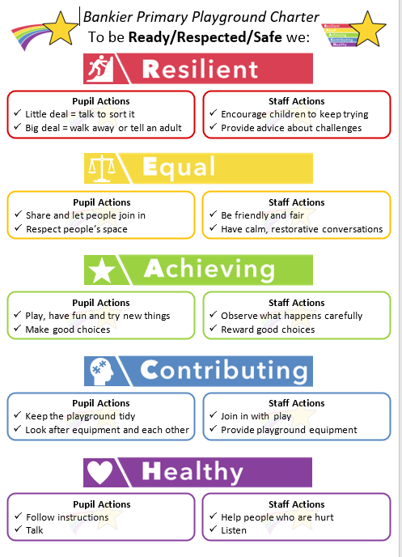
Pupil voice is embedded in school processes and procedures. Pupils worked collaboratively with staff to co-create school and playground charters. Each individual class has their very own charter which is co-created at the start of every academic year.

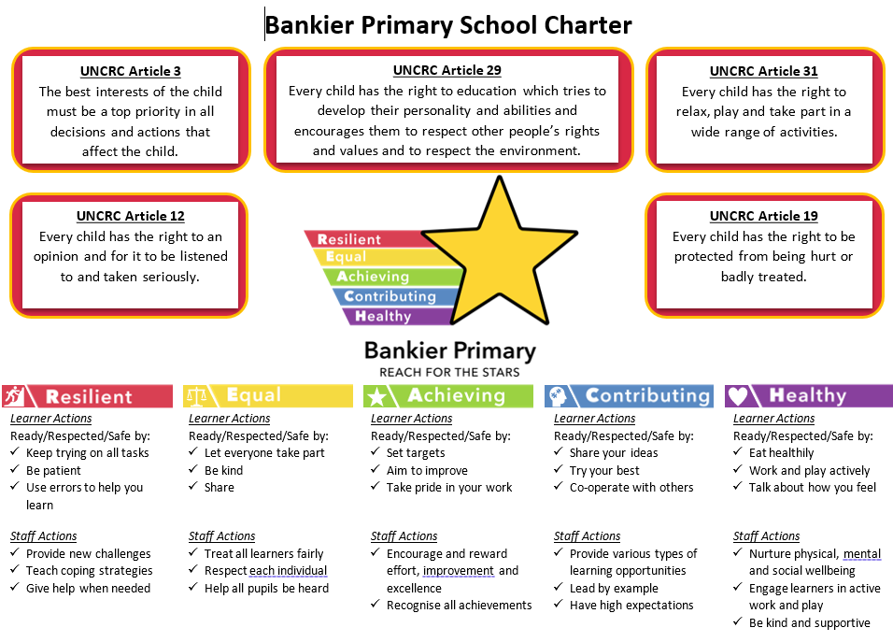

Partnership Working

Bankier is well regarded in the local and wider community. There are good relationships between the school, parents / carers, a wide variety of community groups and local businesses. We pride ourselves on the quality of the relationships within the school and wider community. We have had a long established link with Haggs Parish Church which is Church of Scotland although Bankier PS is non-denominational. We also invite Father Hendry of St Luke’s to any appropriate school events.

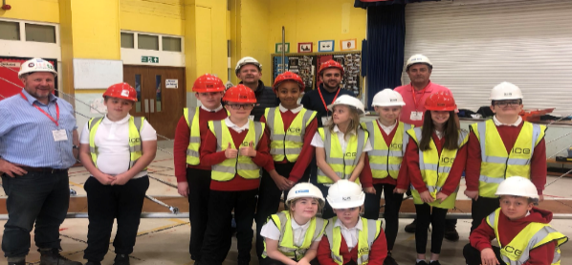
We have very close links with Cloybank Estate, Bankview Nursing Home and we work well with the Community Learning and Development Team. We have links with Stenhousemuir Football Club and our Active Schools Team who offer after school clubs. Our links with local people, often former pupils or parents have helped us to deliver a very successful range of events in the school. Local businesses and industry partners help us facilitate the development of the young workforce.

Robot Workshop- MYOW Forth Valley
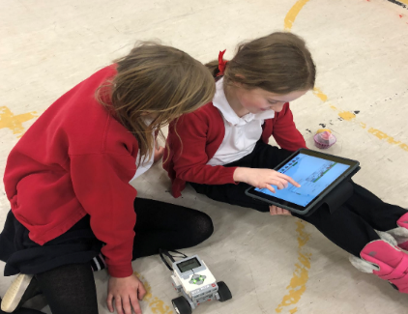
Bridge Building with Balfour Beattie

Development of pupils’ mental, social and emotional wellbeing
The school is committed to supporting the development of the whole child and as a result, wishes to encourage their holistic wellbeing.
Mental, social and emotional wellbeing is supported in the following ways;
- Creating a school ethos which, in every way possible, gives value to these aspects of development, especially by providing an environment which is both caring and challenging and which provides opportunities for exercising rights and responsibility.
- Ensuring that staff and adults in the school act as positive role models for pupils.
- Providing opportunities for members of the school community to come together reinforcing shared values.
- Providing rich opportunities across all areas of the curriculum to develop mental, social and emotional wellbeing.
- Taking every opportunity within the curriculum and across the wider work of the school to celebrate diversity and promote equality.
A range of new local services, digital support and self-help information for school-aged children are available here: Falkirk Community Mental Health and Wellbeing (glowscotland.org.uk)

Religious Instruction and Observance

Religious Instruction
Schools have a statutory duty to provide Religious Instruction in the timetable. This aims to promote a knowledge of the Christian and other faiths, and encourage children and young people to develop enquiring minds through investigating spiritual, moral and philosophical issues.

Religious Instruction may include visits to local places of worship, and/or visits from representatives of places of worship. This helps children and young people to develop knowledge and understanding of faiths, especially those with which they are less familiar.

Ultimately, pupils in the upper secondary school can gain a qualification through the study of Religious, Moral and Philosophical Studies at Higher and Advanced Higher Levels. These courses further develop young people’s skills in logical thinking, methodical enquiry and ways of expressing ideas effectively.

Religious Observance/Time for Reflection
Religious Observance, which may take the form of a Time for Reflection, is held at least six times a year, in addition to traditional celebrations central to the life of the school community. Religious Observance will often (but not necessarily) take the form of an assembly.

Withdrawal from Religious Instruction and Religious Observance/Time for Reflection
Parents who wish to exercise their right to withdraw their child from religious observance are encouraged to discuss their intention with the Headteacher in the first instance to enable them to make a fully informed decision. Thereafter parents who wish to proceed to withdraw their child(ren) should notify the Headteacher in writing. This is so that alternative educational activities can be planned for their child(ren) during times of Religious Instruction and/or Observance.

Pupil Conduct
A genuine partnership between the school and family is necessary to ensure the best possible standards of pupil conduct are shared, understood and underpin every interaction between children/young people, parents/carers and school staff.
Pupils are expected to set themselves high standards in appearance and behaviour. School rules are devised to encourage the maximum amount of self-discipline. The rules make clear what is expected of pupils, and how they are required to behave. The general aim is to produce an atmosphere of friendly co-operation, encouraging respect and consideration for other persons and for property. A behavioural agreement is included in the School Enrolment Form that parents complete when enrolling their child(ren).

Restorative Approach To Bullying Behaviour
Whilst many believe that children who display bullying behaviour should be punished, it is widely accepted that this type of response can at times be ineffective, and make the situation worse.

The adoption of restorative approaches is evidenced to be a more effective response than traditional methods. Pupils are given the opportunity to accept responsibility for their actions, recognise the harm done and are supported to find restorative responses to the harm they have caused.
There are times where sanctions are appropriate; exclusion is seen as a last resort and carried out when incidents fall within the legislative criteria.

Falkirk Council has a responsibility to provide an education for all pupils and to challenge and address bullying behaviour. Whilst appropriate action will be taken by the school, it is also important that all parent/carers, work with the school to resolve any issues in the best interests of their child or young person.

Parents can access Falkirk Council’s Anti-Bullying Policy, ‘Promoting Positive Relationships in Falkirk’s Educational Establishments; on the Council website: www.falkirk.gov.uk/services/schools-education/policies-strategies/anti-bullying-policy.aspx

*Please note, our Anti-Bullying Policy is due to be updated during the 2024-25 school year.

Section Three – School Curriculum

Curriculum for Excellence

Curriculum For Excellence – Learning to Achieve

- Learning to Achieve - Our core educational policy.
This describes in detail how Curriculum for Excellence will be delivered in our educational establishments. We use Learning to Achieve along with the national guidance to monitor, develop and improve outcomes for children and young people.

- Curriculum for Excellence – Bringing learning to life and life to learning.
Curriculum for Excellence is the vehicle by which we deliver a Quality Education across the 4 Contexts of Learning. It aims to raise standards, prepare our children for a future they do not yet know and equip them for jobs of tomorrow in a fast changing world.

Curriculum for Excellence balances the importance of knowledge and skills. Every child is entitled to a broad and deep general education, whatever their level and ability. It develops skills for learning, life and work, bringing real life into the classroom, making learning relevant and helping young people apply lessons to their life beyond the classroom. It links knowledge in one subject area to another helping make connections in their learning. It develops skills which can enable children to think for themselves, make sound judgements, challenge, enquire and find solutions.

- Responsibility of all
Every single teacher and practitioner will be responsible for the development of literacy and numeracy and health & well-being from Early Level through to Senior Phase.

Teachers and practitioners will share information to plan a child’s learning journey from 3-18, helping their progression from nursery to primary, primary to secondary and beyond, ensuring each transition is smooth. They’ll ensure children continue to work at a pace they can cope with and with challenge they can thrive on.

There is an entitlement to personal support to help young people fulfil their potential and make the most of their opportunities with additional support wherever that’s needed. There is an emphasis by all staff on looking after our children’s health and well-being; to ensure that the school is a place where children feel safe and secure.
GLOW, Scotland’s unique, world leading, online network supports learners and teachers. Learners have individual access to GLOW through a username and password issued by school.

Developing the Young Workforce
Developing the Young Workforce (DYW) this programme builds on the foundations already in place as part of Curriculum for Excellence.

Collaborative working between early years, primary and secondary alongside partnership working with local employers and businesses enhances your child’s experiences early years to their point of exit from school. Curriculum planning and structures in schools have continued to evolve progressively as new qualifications have been introduced alongside traditional subjects. There is now on offer a wide range of opportunities for young people to develop their employability skills, gain experiences of the world of work and incorporate work-based learning elements together with employers to explore direct pathways into employment.
Pupils from Primary 1 to Primary 7 participate in the Bankier Skills Academy on a weekly basis. The Bankier Skills Academy promotes skills for learning life and work. Children are arranged in vertical groups across each stage and lessons are delivered on social enterprise, thinking skills, leadership, employability and soft skills.
Please contact the headteacher if you would like any further information about the curriculum within our school.
For further information on Learning in Scotland please access the following link:
A summary of Developing the Young Workforce (DYW)

In Bankier Literacy, Maths and Numeracy and Health and Wellbeing are the top priority. However, we have a special emphasis on science and ICT – particularly to teach internet safety. In addition, we have specialist teachers of PE and Art. There are opportunities for instrument tuition – double bass, violin and piano. There is a residential trip for Primary 7 pupils. Pupils learn in discrete areas or through linked learning which we call interdisciplinary learning. Teachers plan learning activities based on the Experiences and Outcomes of a Curriculum for Excellence. Children are offered a flexible pathway through a rigorous framework of skills. These skills are assessed and tracked throughout the school.

Of course, some children might exceed the expected level and be progressing to third level in P7 Alternatively, some children experience learning differences that may mean they are not able to achieve these expected levels. There are support measures for these children.

The Authority provides support for pupils who need to develop English as an additional language. The Central Scotland Community Interpreting Group offers the services of training interpreters and translations for those parents who require it.
Scots is taught to children in all stages. French is taught at stages P5-P7.

Social, Moral and Religious Education (RME) are inter-related and enable children to develop understanding of religion and to show responsible attitudes through care, respect and concern for others within our multi-cultural society. Assemblies are held most weeks. Religious observance is restricted to some of the weekly assemblies, visits from the minister and others. The RME programme itself does not incorporate religious observance. Parents who wish to exercise their right to withdraw their child from religious instruction and /or observance should contact the Headteacher, in writing, and alternative arrangements will be made for your child.

Details of curricular policies and guidelines can be found on the school’s website at: bankierprimaryschool.co.uk

Learning to Achieve is our core educational policy. It describes in detail how Curriculum for Excellence will be delivered in our educational establishments. We use Learning to Achieve along with the national guidance to monitor, develop and improve outcomes for children and young people.

In Bankier Primary, there are well established, innovative learning and teaching methods such as active literacy, cooperative learning, thinking hats, multiple intelligences, interdisciplinary learning, storyline and formative assessment. These are used in a balance with other more traditional methods such as rote learning.
Please contact the headteacher if you would like any further information about the curriculum within our school.

Play Pedagogy and Active Learning
Curriculum for Excellence emphasises the value of an active learning approach. Active learning is engagement of the brain whilst participating in learning experiences.

In the early years, children will have a range of learning experiences that include planned and purposeful play and stimulating learning which engages and challenges children’s thinking using real life and imaginary situations.

As children progress through school they continue to be involved in active learning experiences which give them ownership of their own learning, encourage co-operative working and utilise skills required for learning, life and work.

Planning Children’s and Young People’s Learning

Practitioners use a variety of approaches to ensure that pupils understand the purpose of their learning and are clear about how to be successful. A variety of planning approaches are used to ensure that experiences are progressive, skills – focused and meet pupils’ learning needs. Often individualised targets help pupils to assess their own learning.

Learning at Home

Partnership with parents is crucial to provide the best possible learning for pupils. Parents are the primary educators of their children and they entrust teachers to utilise their knowledge and skills to facilitate optimum learning. Best practice builds on the learning children already have on entering school. Partnership with parents includes cooperation in all aspects of learning and particularly in disciplinary matters. Partnership can take many forms and includes parent helpers coming into school, membership of organisations such as Bankier Helping Hands (see below), attendance at parents’ evenings, open days, workshops and other events.

Home Learning will be distributed on a Monday each week via Class Dojo. There will be several suggested tasks for you to complete with you child:

Spelling
The spelling words for your child’s spelling group will be shared each week. This will allow you to practise these words with your child in preparation for their weekly spelling test on a Friday. There will be a grid provided that will give you suggested tasks you can do to help your child learn these words.

Mathematics
A variety of different numeracy and maths tasks will be shared over the course of the term. This could be to practise one of the times tables, to practise “Learn Its”, or to play an online game that supports the learning being done in class.

Reading
Your child will be given a piece of reading to do at home. This could be in the form of a school reading book or could be reading assigned from our new online reading scheme. We will also provide you with details of how to sign in to “Borrow Box”, an e-book library through Falkirk Council.
Homework Jotter

Your child will receive a jotter that can be used to support the completion of homework tasks. In line with school homework policy, this jotter will not be collected in and is purely for use at home as you see fit. If your child requires a new jotter, please send a Dojo message and a new jotter will be provided.
Termly Overview

A Termly Overview will be provided at the start of each school term. This is designed to give families a snapshot of what pupils will be learning during the course of the term. This will give scope and freedom to families to extend pupil learning by for example providing ideas for library books that could be borrowed or for family trips that could be planned. It can also be used by families to help generate conversation with children around what they have been doing in school.

Care of Books / Materials
To enable us to provide the best possible education for your child, every care should be taken to look after the school’s resources and facilities. Parents are asked to remind their child(ren) that all school equipment and fitments should be used with care.

Books and learning resources which are lost or destroyed must be paid for, either wholly or in part, depending on the age of the resource. Any loss of school or Council property should be reported immediately to the school.

Sensitive Aspects of Learning

The Health and Wellbeing Curriculum in Scotland, as outlined by Education Scotland, aims to promote the holistic development of children and young people, supporting them to lead healthy, active, and fulfilling lives. It focuses on the physical, emotional, mental, and social aspects of health, fostering positive attitudes and behaviours that contribute to overall well-being.

Key Areas of the Health and Wellbeing Curriculum include:
- Mental and Emotional Wellbeing
The curriculum emphasizes emotional literacy, resilience, and mental health awareness. It encourages children to understand and manage their emotions, build relationships, and develop self-esteem. These aspects are embedded in daily school life, with experiences and outcomes guiding educators in creating supportive environments that promote mental and emotional well-being.
- Physical Health and Wellbeing
Physical health is addressed through promoting regular physical activity, healthy eating, and the development of skills to make informed decisions about lifestyle choices. This includes not only exercise but also understanding how nutrition and rest contribute to well-being. The curriculum encourages active lifestyles, helping children understand the connection between physical health and mental/emotional health.
- Sexual Health and Relationships Education
The curriculum includes a comprehensive approach to Sexual Health and Relationships, which helps students understand relationships, sexuality, and their responsibilities. Teaching on sexual health is age-appropriate and progresses from early years to secondary school, in line with students' developmental stages. Key elements of SHR education include:
  - Understanding relationships: The focus is on building respectful, healthy relationships, teaching empathy, consent, and communication skills.
  - Consent and respect: Education includes clear guidelines on consent, personal boundaries, and the importance of mutual respect in all types of relationships.

- Drug Awareness and Prevention
Drug education is another key aspect of the curriculum. It helps students understand the risks and consequences of using substances such as alcohol, tobacco, and drugs. The goal is to prevent misuse by fostering awareness and resilience. Through structured lessons and activities, students learn about:
  - The effects of drugs on physical and mental health.
  - Strategies for resisting peer pressure and making informed choices.
  - Understanding the legal, social, and psychological consequences of substance misuse.
Education Scotland’s guidance highlights the importance of early intervention, clear communication, and creating a safe environment for young people to discuss their concerns and questions regarding drugs and alcohol.

his context, the Authority provides a degree of financial and administrative support for leagues, competitions, festivals and similar events but it is recognised that, again, the help of parents and the community is irreplaceable. Quite separately, the Council and other partner organisations also undertake to organise and administer certain events and many schools take part in these.

There is a range of extra curricular activities available for pupils during lunchtime and after school. Parents will be informed about these by the school. In addition to in-school activities, classes also make regular educational visits and field studies. Wherever possible, these visits are linked to pupils’ class work.

Where participation involves children travelling or staying late after school, written permission for children taking part is required from parents

Facilities for Physical Education and Outdoor Activities
The gym hall has a variety of apparatus for physical education within the school. There are many games and activities painted on the ground and we have wall mounted basketball hoops for all stages. We also have an adventure trail, cycle track, climbing wall and assault wall. Many after school clubs are in place using the school for activities such as dance, rugby, mini tennis, badminton, orienteering and cross-country. We also have access to the Sports Centre adjacent to the school during school hours.

Active Schools
The goal of Active Schools is to provide more high quality opportunities to participate in sport within schools. We also aim to ensure that these opportunities are well connected to and supported by other local, regional and national partners.
We work with Physical Education (PE) professionals to ensure better coordination between PE and school sports and also to encourage the development of more physically active children and young people.
While our focus is sport, our activities connect to the wider landscapes of play, dance, exercise and active living – we know that a joint effort is required to deliver the health and performance related fitness our children and young people deserve.
Within Falkirk Council we have an Active Schools Manager, nine Active Schools Coordinators (Primary) and nine Active Schools Coordinators (Secondary). The Coordinators work within their respective Primary and High Schools clusters to provide further opportunities for physical activity, sport and play. We also have a coordinator designated to disability sport.
Active Schools Falkirk | Falkirk Council (falkirkleisureandculture.org)
Follow us on @falkirksport

Assessment and Reporting
There are a variety of ways to assess progress and ensure that children and young people achieve their potential. Effective assessment practice within schools and establishments include:
- Learner involvement in setting personal targets and next steps
- On-going self-evaluation by learners, staff and school leaders
- Identification of strengths and next steps
- A range of approaches to assessment
- A variety of evidence gathered informally on a day to day basis or formally at certain points throughout the year (not exclusively - Teachers’ professional judgement, Scottish National Standardised Assessments, National Qualifications)
- Moderation of standards using Education Scotland Benchmarks
- Consideration of data analysis and performance information

Achievement of a Level & Scottish National Standardised Assessments (SNSA):
Learner’s progress is defined within the following levels:
Level | Stage
Early | Pre-school and P1 however may be later for some
First | To the end of P4 however may be earlier or later for some
Second | To the end of P7 however may be earlier or later for some
Third & Fourth | S1 – S3 however this may be earlier for some
Senior Phase | S4-S6 and college or other means of study

Achievement of a level means that the learner has achieved a breadth of learning across the curriculum area and has met the appropriate benchmarks; that they have responded consistently well to the level of challenge in their learning and can apply what they have learned in new and unfamiliar situation.
From August 2017, National standardised assessments have been introduced to all schools across Scotland in aspects of reading, writing and numeracy, for all learners in P1, P4, P7 and S3.
These assessments sit alongside a wide range of other evidence including ongoing classroom assessment of all aspects of literacy and numeracy. They cannot be used alone to confirm judgements of achievement of a level.

- Within schools and establishments, finding out about your child’s progress includes:
  - Attending parents’ information evenings
  - Discussing progress with teacher staff and school leaders by appointment
  - Attend open evenings/afternoons including “meet the teacher” events
  - Reading learning logs or diaries (which usually invite parents/carers to comment)
  - Summary Reports (sent home to parents/carers including an invite to make comments)
  - Social media updates from staff and/or the school
Further information about what data is collected about your child is given in section 5 of this handbook.
Reporting at Bankier Primary School

Bankier Primary School has a holistic approach to reporting on children’s learning. Below you will find a table outlining how we share information with you and when. There are two formal parents’ evening every academic year and two formal report cards are issued.

Reporting to Parents/Carers at Bankier Primary School
When? | How? | Why?
Aug | Meet the Teacher Event | To build relationships
Nov  May | Progress Reports | To share your child’s progress linked to our  School Values of Achieving and Contributing
Nov  Jun | Parents’ Evening | To discuss your child’s progress
Weekly | Class Dojo posts | To share class learning
Termly | Class Termly Overview | To explain what your child will be learning
Bi-Annually  (e.g. Sep & Feb) | Additional Support Needs meetings/  sharing of targets | Home-school partnership to support  children with Additional Support Needs
Annually | Class Assembly | Share class learning
When relevant | Reaching for the Stars Certificates  and Brilliant Bairn Certificates  Class Dojo individual message  Informal discussion with class teacher  (e.g. when collecting child)  Parent Meeting with Senior Leadership Team | To share your child’s achievements  To discuss specific questions/events/concerns  To discuss specific questions/events/concerns  To discuss specific questions/events/concerns
On-going | Noticeboard updates and  School Website information | General information about school, events, useful links

Section Four – Support for Pupils
Getting It Right For Every Child (GIRFEC)
Getting it Right for Every Child (GIRFEC) is underpinned by the United Nations Convention on the Rights of the Child (UNCRC). The UNCRC was produced in 1989 and contains 54 Articles specifically for children, recognising the special care and protection they need throughout childhood to experience the full range of human rights: civil, cultural, economic, political, and social rights.
The Scottish Government is committed to recognising, respecting, and promoting children’s rights as part of its wider commitment to improving life chances for all children and young people. The UNCRC lies at the heart of the Scottish Government’s policy and practice.
UNCRC: the foundation of Getting it right for every child - gov.scot (www.gov.scot)
Getting it Right for Every Child (GIRFEC) is the Scottish Government’s approach to improving children’s services. The wellbeing of all children and young people is at the heart of GIRFEC. Services must work together with children, young people, their families, and those responsible for their care, to provide quick and effective support. To support the GIRFEC approach, the Children and Young People (Scotland) Act 2014 ensure key parts of GIRFEC are within law.

Wellbeing
The GIRFEC approach looks at eight areas of wellbeing. These are recognised as required areas which children and young people need to flourish both now and in the future.
The eight wellbeing indicators are:

• Safe • Active
• Healthy • Responsible
• Achieving • Respected
• Nurtured • Included

These enable the adults responsible for the care and wellbeing of children and young people to provide them with support. These areas help children and young people, families, those responsible for their care, and services, to identify any needs. Through a collaborative approach children and young people, families, those responsible for their care, and services will use these eight wellbeing indicators to identify any need and respond with appropriate planned solutions and supports.
This approach provides a common language and areas to focus on when gathering information about a child and young person’s world, to ensure they are growing and developing (UNCRC Article 6).
Policies & strategies - Getting it Right for Every Child (GIRFEC) | Falkirk Council

Main Contact

In 2019, the Scottish Government repealed the relevant sections of the Children and Young People (Scotland) Act 2014 relating to the Named Person service. A named person was defined as a central point of contact for children, young people, and parents. This person had the responsibility for providing families with information for getting the support if, and when, they needed it. As a result of the Scottish Government’s decision, education authorities are no longer legally required to provide this service.

Every child and young person will still have a main contact within a school establishment to support and promote their wellbeing. The role of the main contact is to act as the first point of contact for children, young people, those responsible for their care, and families.

If the main contact is not available, please speak to another member of staff who will be able to help. During school holidays an officer from Children’s Services Central Team will provide the advice and support you may require

Family Support Services

Family Support Services work in partnership with families, schools, and other agencies to support young people’s wellbeing from early intervention to more intensive support.

Children, young people, and families may require additional support at different times in their life due to changing circumstances, such as: following a bereavement, trauma, illness, increased anxiety, and transition points in life. Support can be tailored to meet the individual needs of children, young people, and families, when they need it most and as locally as possible.

A request for support can be made through a member of school staff (main school contact) who will be able to talk with you, gather information and your family’s views. This helps identify the most appropriate service. Support can be delivered in school, at home or in the community, on an individual or group basis

Protecting Children & Young People
Article 19 of the UNCRC states that all children and young people have a right to be protected from violence, abuse and neglect. Everyone who works with children or young people has an important role in keeping them safe. Any individual could identify a concern that a child or young person may be at risk from abuse, neglect, exploitation or violence.
Falkirk Council has clear procedures for all staff to follow when there are concerns that a child might have been abused, are at risk of abuse or are likely to be exposed to significant harm. Sharing relevant information is an essential part of protecting children. Where there is concern about a child’s safety or welfare, relevant information will be shared with police or Social work without delay, provided it is necessary, proportionate and lawful to do so.
All concerns that may indicate a risk of significant harm will lead to an Inter -agency referral discussion (IRD). This multi-agency forum involving Social Work, Police, Health and Education share relevant information they hold about the family and will decide on the next steps that are required, whether to progress an investigation and make plans to ensure the immediate safety of the child.

Additional Support Needs
As with all local authority schools in Scotland, this school operates under the terms of the Education (Additional Support for Learning) (Scotland) Act 2004 (amended 2009) and its accompanying Code of Practice. This has been strengthened through the Children and Young People (Scotland) Act 2014.
Further details of the policies and procedures can be found on the Falkirk Council website:
www.falkirk.gov.uk/services/schools-education/additional-support-needs/

Children, young people, and families will work together with this school, other agencies and professionals to provide the best possible educational provision to meet their needs within the resources available. This may include working with Social Work Services, Educational Psychology Service, and the National Health Service.

Support for Pupils

The school makes provision for pupils with additional support needs throughout their education (UNCRC Articles 23, 28 and 29):
- each teacher differentiates the Curriculum for Excellence within their class to provide educational targets and objectives suited to their age and stage of development
- the school has an experienced Support for Learning Teacher or Pupil Support Teacher to co-ordinate and organise support for children
- the school can utilise Support for Learning Assistant time for exceptional cases

For the children and young people who require further support, the GIRFEC wellbeing indicators, and other assessments, may be used to identify their additional support needs. Those involved in helping to complete a rounded picture of assessment are referred to as the Team Around the Child (TAC) (UNCRC Article 3).
Members of the TAC may include the following. Depending on the circumstances, others may be involved:
- the child or young person (UNCRC Article 12)
- parents or carers
- others responsible for the care of the child or young person
- school staff
- social work
- Children’s Rights Officer
- ASN Advisor

The Team will also draw up and review plans to meet the identified needs. Their activities are co-ordinated by the Lead Professional, who is responsible for ensuring plans are implemented and has an overall picture of the child or young person’s progress.
If you believe your child may have unrecognised additional support needs, your first point of contact should be the child’s class teacher (primary) or their Guidance teacher/Pastoral Head (secondary).

Disputes and Resolution in Additional Support Needs

Schools and Early Learning Centres (ELC) do their best to support and respond to the needs of their children and young people. It is important for good communication between home and school so that should a problem arise, it can be identified and discussed as soon as possible.
In the first instance, the school or ELC should be contacted directly. If the matter cannot be satisfactorily resolved, services from centrally based staff may be called upon: the Additional Support for Learning Adviser, the Educational Psychologist or the school’s attached Team Manager. Children’s Services also commission independent mediation through Children in Scotland. This is a free service to parents, carers, and young people. It offers an independent mediation service by fully trained, experienced mediators in neutral venues and operates with a child- centred approach. Their services, called Resolve, may be arranged by the Additional Support for Learning Adviser, or accessed directly by parents and carers.
Parents, carers and children or young people with additional support needs can also seek independent advice and support through:
- Enquire – the Scottish advice and information Service for additional support for learning managed by Children in Scotland: www.enquire.org.uk, info@enquire.org.uk 0345 123 2303
- Resolve: ASL - to contact the service, or to find out more: www.childreninscotland.org.uk, info@childreninscotland.org.uk Sandra Mitchell, Mediation Manager smitchell@childreninscotland.org.uk Children in Scotland, Thorn House, 5 Rose Street, Edinburgh EH2 2PR
- Scottish Independent Advocacy Alliance - www.siaa.org.uk, enquiry@siaa.org.uk 0131 510 9410
- Let’s Talk ASN Scotland - is a Scottish Government funded service for the parents of children with additional support needs and run in partnership with Barnardo’s. The service provides legal representation in appropriate education law cases to parents or pupils. It also provides advocacy support for families with a right of reference to the ASN Tribunal for Scotland., c/o Govan Law Centre, letstalkasn@edlaw-org.uk 0141 445 1955
- Children and Young People’s Commissioner Scotland - www.cypcs.org.uk/about/

More detailed information about Falkirk Council’s ASN service can be found here:
Falkirk Council Additional Support Needs | Supporting Children & Young People with Additional Support Needs Across Falkirk Council (glowscotland.org.uk)

collaboration with teachers, parents and other professionals to support children and young people with their learning and development, and to make the most of their lives.
Every school and pre-five establishment has a link Educational Psychologist who provides consultation, assessment, intervention, training and project work. The Service works within the Staged Intervention Approach of Children’s Services. We expect that all schools will have undertaken appropriate assessment and intervention at stage 2 before asking for educational psychology assistance.
The school must obtain the agreement of parents and, where appropriate, the pupil before involving the Educational Psychology Service. Further information is on the website https://blogs.glowscotland.org.uk/fa/epservice
As a statutory service we are required to publish a privacy notice which is available here: Privacy notices: Schools & education - Educational Psychology Service | Falkirk Council
Parents can contact the service directly on Educational Psychology Service educationalpsychologyservice@falkirk.gov.uk or 01324 506600. Please ask for the link psychologist for your child’s school or Nick Balchin, the Principal Educational Psychologist.

EPS Prioritisation
The Educational Psychology Service does not operate a waiting list system. We aim to be responsive as a service and so we do this through a prioritisation system.

A. Respond to statutory requests within agreed timescales these are written request for an educational Psychology Assessment from the parent, child/young person or the local authority from the Additional Support Needs Team
OR
B. Prioritise with school manager/cluster approximately termly and prioritise as follows:
  - Critical incidents
  - Children at risk of education placement breakdown
  - Children where there is evidence that high levels of adaptation are required
  - Assessment in relation to significant Additional Support Needs or placement change
  - Exploratory Assessment to identify areas of concern

Transitions

There are detailed transition arrangements in place for pupils transferring from our own and other nurseries to the school; from primary to our associated and other secondaries and for pupils moving to or from other primary schools. We transfer rich data in the Pupil Progress Record (PPR), Pupil Progress File (PPF) and other files or transfer forms. We liaise with partner agencies such as family support workers, inclusion and wellbeing, educational psychology, speech and language therapy among others to ensure important information is transferred.

Nursery Class Provision

The school’s nursery class provides places for children aged 3-5 years.
Nursery class provision is non-denominational, which allows children of parents from all religions and beliefs to attend the nursery. Attendance at the nursery class does not however guarantee a place in the school.

Admission to Early Learning & Childcare (ELC) Establishments in Falkirk

ELC places are allocated according to the Early Learning and Childcare Admission Policy. A funded pre-school education place is available for every child aged 3 to 5 years who lives in Falkirk. A funded place can be provided in either a Falkirk Council ELC Centre, private nursery or childminder which is in partnership with Falkirk Council.

Children become eligible for pre-school education as follows:

- For children who reach 3 years of age between 1st March and 31st July the start date will be the beginning of the Autumn Term (August)
- For children reaching 3 years of age between 1st August and 29th February of the following year the start date will be a month after the child’s 3rd birthday.

Parents can apply for a nursery place between 1st December to 28th February each year via the Council’s website https://www.falkirk.gov.uk/services/children-families/early-learning-childcare/elc-admissions.aspx

Please note you will need to create a MyFalkirk account before applying.

Transition from Nursery to Primary

Each establishment has a detailed approach to ensure a smooth transition for children to primary school. This involves nursery and primary staff working together to share information about children’s progress and achievements which will inform future planning.

Primary School Admissions
Children’s Services must set a date each year for the commencement of children’s attendance at Primary school. This date is usually the 3rd or 4th week in August.

When commencing Primary 1 education, your child will normally attend the local denominational or non-denominational Primary school and transfer from it, after Primary 7, to its associated Secondary school. Details of the catchment areas and boundaries can be obtained from the Forward Planning Section – Tel. 01324 506608 in Children’s Services, on the website - www.falkirk.gov.uk or the relevant school.

Pupils who are baptised Roman Catholic and who live within the catchment area of a denominational school are automatically entitled to enrol at the school. All other pupils will require a placing request (see below).

Any movement between denominational and non-denominational schools at year stages other than Primary 1 will require a Placing Request Form application to be completed.

Primary 1 enrolments will be accepted from 1st November until 31st December each year. Parents will receive information regarding the enrolment arrangements via their current nursery in October. Adverts will also be placed in the local press and all nurseries and schools.

Parents of pupils enrolling at a denominational school must also present their child’s RC baptismal certificate. Parents of pupils that are not RC baptised will be required to submit a placing request (see below).

You are still required to enrol your child(ren) at your catchment denominational school (if RC baptised) or catchment non-denominational school (if not RC baptised) even if you do not wish him/her to attend that school.

Information on enrolments will also be available through the Falkirk Council website at www.falkirk.gov.uk.

Children eligible for enrolment are those whose 5th birthday falls between 1st March and the end of February the following year. Requests for enrolment will only be prioritised if Children’s Services receive more requests for enrolment than places available at the school.

Primary to Secondary Transfer

There are a range of activities that take place to ensure that all children are well supported as they move from Primary 7 to 1st year, and these are all decided by each secondary school and its associated primary schools.

Generally, visits take place in the summer term, with a programme of activities for pupils in classroom relating to their secondary subjects. Sporting and social activities may also be planned. Pupils, therefore, become familiar with the new school, their new teachers, and their new classmates.

Clusters also arrange for secondary school subject teachers to visit Primary 7 classes from time to time, with the cluster agreeing each year which subject areas should be the focus for these. Opportunities for senior pupils from secondary schools to visit classes in their associated primaries offer further reassurance and can help supportive peer relationships to be developed before S1 begins.

Most secondary schools also have an information evening for parents of Primary 7 children at which they can gain information about uniform, lunchtime arrangements, school clubs, etc.

Pupils with Additional Support Needs

Secondary school Pastoral and Support for Learning teachers make visits to the Primary 7 class to get to know the children and their needs, including any Additional Support for Learning needs. Visits by Support for Learning staff sometimes take place as early as Primary 6 to help with additional arrangements for those children for whom the move to secondary school may present challenges.

Moving to the denominational secondary school

Children who are baptised Catholic

With the exception of some pupils at St Patrick’s PS, pupils who are in Primary 7 in denominational primary schools (Sacred Heart PS, St Andrew’s PS, St Mary’s PS, St Francis Xavier’s PS and St Joseph’s PS) move to St Mungo’s HS.

Pupils in Primary 7 at St Patrick’s PS attend St Modan’s HS in Stirling.

Children who are non-Catholic

Parents of non-RC baptised pupils who were enrolled through a Placing Request at a denominational primary school must submit a further Placing Request if they wish them to transfer to St Mungo’s High School. These pupils are, otherwise, automatically entitled to transfer to their catchment non-denomination secondary school.

Moving between denominational and non-denominational schools

Parents who intend to send their children to St Mungo’s HS from a non-denominational primary school, or from a Catholic primary school to their catchment non-denominational high school, should make known their intentions both to the primary school and the secondary school as soon as possible. This enables the necessary transfer arrangements to be made. A placing request will also be required.

Catchment Secondary School


At the end of P7 pupils normally transfer to:

Denny High School
Herbertshire Park
Denny, FK6 6EE
Tel No.: (01324) 827440

Placing Requests
As a parent, you have the right to make a Placing Request for your child(ren) to be educated in a school other than the local school. Applications for Primary 1 and Secondary 1 Placing Requests to commence school in August will only be accepted following the publication of an advert in the local press inviting applications in early December.

Every effort will be made to try to meet parental wishes, but you should note that it is not always possible to grant every Placing Request. You should also note that a successful Placing Request for one child does not guarantee a successful one for another child. A parent could, therefore, end up with children attending different schools.

Primary 1 children must also be enrolled at the catchment area school whilst awaiting the outcome of their Placing Request Application. If the Placing Request is granted, the child’s enrolment at the catchment school will automatically be withdrawn by Children’s Services.

Placing Requests can only be approved when there are sufficient places remaining in the class after all catchment area children have enrolled and if staffing and accommodation at the school are able to meet the numbers of Placing Requests at that school. Children’s Services will also reserve places in a class for catchment pupils they expect to move into the area during the school year.

If more Placing Requests are made for admission to a particular school than places available, these Requests will be prioritised according to Falkirk Council’s Admissions Policy and requests accepted and refused accordingly.

Online placing request applications can be made via the Council’s website www.falkirk.gov.uk/placingrequests. Written application forms are available from all schools and from Children’s Services. Written applications must be returned to the Director of Children’s Services, Suite 1A, Falkirk Stadium, 4 Stadium Way, Falkirk, FK2 9EE. Placing requests for Primary 1 and Secondary 1, commencing in the next school session, should be made by the 15th March each year. Reponses will be issued no later than 30th April.

Your Placing Request will be considered against a set of criteria which is set out in the Council’s priorities for admission.

Any Placing Requests received after the 15th March for Primary 1 and Secondary 1 will not be considered in the first round of Placing Requests. Parents / Carers will be notified of the outcome of their request within 8 weeks of receipt.

As soon as a decision has been made, you will be notified of the result. If your Placing Request is successful, you will be asked to contact the school to establish arrangements for enrolment.

Mid Session Transfers
You may make a Placing Request at any time during a school session. If your child is experiencing problems at school, you are advised to discuss the matter with the Head Teacher prior to making a Placing Request. Completing the Application Form does not guarantee a place for your child at your chosen school.

Transport for Placing Requests
If a Placing Request is successful, parents will be responsible for the safety and transportation costs of their child to and from their chosen school.

Section Five – School Improvement
Raising Attainment

Monitoring performance and using the resulting information to secure improvement is an important part of the work of head teachers, school staff and officers within Children’s Services. Head Teachers regularly track pupils’ progress at meetings with each teacher to ensure that progress is maintained and to identify effective strategies progress when necessary.

Standards and Quality Report

Every year each school publishes a Standards and Quality report which highlights the school’s major achievements.

Standards and Quality Reports – Operational Guidance

Schools and centres must provide an annual Standards and Quality Report (SQR) as a record of the progress made with the annual improvement plan. The SQR should be based on the results of on-going self-evaluation which is rigorous, effective and based on consideration of impact. This self-evaluation should be informed by How good is our school? 4th edition (HGIOS?4) and/or How good is our early learning and childcare? (HGIOELC?) and How good is OUR school? It should give a clear indication of where the school is now in relation to its process of continuous improvement.

It should state clearly and briefly the progress towards the National Improvement Framework (NIF) priorities and drivers and Children's Services NIF Improvement Plan priorities. The report should be written using evaluative language.

The National Improvement Framework’s key priorities are:

- Placing the human rights and needs of every child and young person at the centre of education
- Improvement in children and young people’s health and wellbeing
- Closing the attainment gap between the most and least disadvantaged children and young people
- Improvement in skills and sustained, positive school-leaver destinations for all young people
- Improvement in achievement, particularly in literacy and numeracy.

The drivers of improvement identified in the NIF are:
- School and ELC leadership
- Teacher and practitioner professionalism
- Parent/carer engagement and family learning
- Curriculum and assessment
- School and ELC improvement
- Performance information

School Improvement Plan

The School Improvement Plan (SIP) is the main document for planning school improvement. A maximum of 6 key developments are planned in any one session. These are prioritised through a process of auditing and consultation as well as considering important local and national initiatives. Other considerations are the results of attainment data and information provided by Education Scotland. The key aim for any improvement plan is to raise attainment and achievement but it also addresses issues such as inclusion and equity. The SIP is used during school inspections. Parents can support the SIP process by participating in audits, surveys and consultations. The Parent Council is always consulted on the content of the SIP.

School Improvement is monitored by head teachers, school staff and officers within Children’s Services as well as members of the Inspectorate and using the resulting performance information to secure improvement is an important part of the work

The School Improvement Plan (SIP) and the Standards and Quality Report which gives details of the school’s main achievements are available on the school website: bankierprimaryschool.co.uk

Transferring Educational Data About Pupils

The Scottish Government and its partners collect and use information about pupils in schools (e.g. the number and characteristics of pupils, their attendance, absence and exclusions, their attainment and their destination when leaving school) to help to improve education across Scotland.

Information on how this data is used and what the Scottish Government and its partners do to protect the information supplied to them can be found via the link below:
https://www2.gov.scot/Topics/Statistics/ScotXed/PrivacyInformation

For more information on why we transfer educational data to the Scottish Government and third parties, please see the Primary page on the Falkirk Council website : www.falkirk.gov.uk/privacy

Concerns
If you have any concerns about the ScotXed data collections you can email the Head of Schools Analysis at ScotXed@gov.scot or write to Education Analytical Services, Area 2D, Victoria Quay, Leith, EH6 6QQ.

Websites
You may find the following websites useful.
- https://education.gov.scot/parentzone/ - parents can find out about everything from school term dates to exam results. This site also offers information for pre-5 and post school. It also lists relevant publications for parents and provides hyper-links to other useful organisations.
- https://education.gov.scot/inspection-reports - parents can access school and local authority inspection reports and find out more about the work of Education Scotland.
- https://education.gov.scot/parentzone/ - parents can find out about individual schools. They can choose a school and select what type of information they need such as Education Scotland reports, exam results, stay on rates and free school meal entitlement.
- www.falkirk.gov.uk- contains information for parents and information on Falkirk schools.
- http://www.childline.org.uk/Explore/Bullying/Pages/Bullyinginfo.aspx - contains information for parents and children on varying forms of bullying and provides help for parents and children who are affected by bullying.
- http://www.respectme.org.uk/ - Scotland’s anti-bullying service. Contains information for parents and children on varying forms of bullying and provides help for parents and children who are affected by bullying
- http://www.ltscotland.org.uk/ - provides information and advice for parents as well as support and resources for education in Scotland
- http://www.equalityhumanrights.com/ - contains information for everyone on equality laws within the government and local authorities.
- Scottish Attainment Challenge: 1. Introduction - Scottish Attainment Challenge: framework for recovery and accelerating progress - gov.scot (www.gov.scot), Scottish Attainment Challenge | Learning in Scotland | Parent Zone (education.gov.scot) and Scottish Attainment Challenge | Learning resources | National Improvement Hub (education.gov.scot)
- Curriculum for Excellence: What is Curriculum for Excellence? | Curriculum for Excellence | Policy drivers | Policy for Scottish education | Scottish education system | Education Scotland
- National Improvement Framework 2022: Education - Achieving Excellence and Equity: national improvement framework and improvement plan 2022 - gov.scot (www.gov.scot) and National Improvement Framework | Learning in Scotland | Parent Zone (education.gov.scot)

Glossary
ASL – Additional Support for Learning
ASN – Additional Support Needs

CFE - Curriculum for Excellence
CLD – Community Learning and Development
DHT - Depute Headteacher

EMA – Education Maintenance Allowance
ESMT- Education Services Management Team
FFB - For Falkirk's Bairns - Integrated Children's Service Plan
FOI – Freedom of Information
FVNHS - Forth Valley National Health Service

GIRFEC – Getting it Right for Every Child
Glow - Scottish Schools National Intranet (Glow doesn’t stand for anything)
HT - Headteacher

LIPs - Local Improvement Priorities
LTA - Learning to Achieve
MFiF - My Future's in Falkirk
NPFS - National Parent Forum of Scotland

PC - Parent Council
PLPs - Personal Learning Plans (personal learning planning)
PT - Principal Teacher
PTA/PA - Parent/Teacher Association/Parents Association

SEEMiS - Management Information Systems (SEEMiS is the pupil database)
SIP - School Improvement Plan
SPTC - Scottish Parent Teacher Council
SQA – Scottish Qualifications Authority

